Putting the Personal Health Information Securely "on the Internet"

Introduction
Diabetes is a kind of commonly known chronic disease characterised by disturbances of fat, sugar, and protein metabolism. [who] Typically, diabetes leads to a high blood sugar level in human body due to the failure of insulin secretion and action. Statistics have shown that approximately 1.7 million Australians have diabetes including both type 1 and type 2 diabetes and this number is increasing by 280 every single day. [diabetes australia website]. Diabetes can cause various symptoms such as blindness, amputations, and heart disease which seriously affect people's health and life quality. [d a website] In 2010, data collected from nearly 400,000 people reveal that only 50% of Australians with diabetes are reaching the healthy glycaemic target level, meaning the remaining 50% are faced with higher risks of medical complications resulted from diabetes. [d a web] Another serious fact is that compared with non-Indigenous Australians, Indigenous Australians experience a much higher possibility of developing diabetes partly due to the inequality in access to health and poor use of health services in remote areas. [diabetes au pdf, 5, 6] On top of this, a large number of people with diabetes are unaware of the situations they are facing until they show some severe symptoms after many years. [3] However, researchers find that early detection of diabetes contribute substantially to the treatment of chronic diseases including diabetes, [valentine 2011] which implies that if people with diabetes can get treatment in the early stage, the risks of developing diabetic complications will reduce considerably.

Taking advantage of the rapid development in the Internet technologies together with the emerging booming market of portable/wearable devices, the idea of building novel, miniaturised sensors attached in household items can be the key to solving the problem of monitoring chronicle diseases such as hypertension and diabetes in a cost-effective way. Over 30 years after the first Internet connection was set up in Australia, now more than 86% of Australian families have access to the Internet at home.[ABStastics] Moreover, 91% percent of the connected households have used mobile or smart phones to gain access to the Internet. [ABS] Meanwhile, the Federal Government has been encouraging telecommunication enterprises like Telstra to get involved in the Mobile Black Spot Program to expand mobile coverage in remote areas in Australia since 2015.[Telstra web] On the other hand, the booming biosensor market has gained an enormous development combined with the powerful artificial intelligence and big data technologies in fields like health informatics and precision therapy. For example, cloud-based communication for health monitoring and emergency assistance integrated in wearable devices helps doctors to monitor their patients' health situations. [sinnapolu]

Our goal is to design a networked information system which uses wireless biosensor-integrated toothbrushes to collect data from people with diabetes. Considering the invaluable privacy behind the data, the designed network must have sufficient resources and abilities to deal with related network threats to ensure the security of these data. Furthermore, integrated with the latest AI and ML technologies, the system is able to analyse the data to offer them with early diagnoses and precision medicine therapy advice regardless of people's social backgrounds and geographical locations.

2. Methods
When developing a secure network, our first step is to conduct a risk assessment to provide strategies for analysing and prioritising risks to information systems and networks.

The very next step for developing a secure network is to ensure business continuity.

Third, we need to take into consideration of the concrete methods for intrusion prevention.

Meanwhile, developing controls is a critical part in developing a secure network. Controls consist of three aspects: preventive controls, detective controls, and corrective controls.

3. Results
3.1 Security Issues and Risk Assessment
3.1.1 Security Threats
Generally, security threats in a network system can be categorised into two broad categories which are ensuring business continuity and preventing unauthorised access.
Three kinds of threats exist in ensuring business continuity. First of all, disruptions are the loss of or reduction in the network system such as a network switch failure. Second, destruction of data which can result from a hard disk breakdown. Third, natural/human-made disasters including fires, earthquakes and terrorist attack can also lead to catastrophic consequences.
Intrusions can also be a threat to our system from both outside networks and within the organisations. External attackers can gain access to organisational data from across the Internet while employees inside the companies can also steal critical information on purpose.
Out of all the security threats mentioned above, we find our major threats are centred around the user information which can be compromised mostly by malware attacks, denial of services attacks and theft of information.

3.1.2 Risk Assessment
In dealing with security threats, it is of critical importance to conduct a risk assessment to view the whole picture of our designed system. The main purpose of a risk assessment is to identify threats and associated controls. The risk assessment framework can provide both professionals and non-professionals knowledge about current threats and any controls that are in place to mitigate the occurrence of threats.
Basically, there are five steps required to complete a risk assessment: developing risk measurement criteria, inventorying IT assets, identifying threats, documenting existing controls, and identifying improvements.
First, we need to develop risk measurement criteria to evaluate the way a security threat could affect the organisation. In the case of setting up networked information system for health monitoring, there are four most commonly considered impact areas to consider which are financial, productivity, reputation and legal.
Second, we should inventory all types of assets including hardwares, softwares, data, or applications. Of all these assets, there is one mission-critical application essential to the survival of our health monitoring system: the health application services we offer to our customers.
Third, identifying threats, especially the major threats can help us create threat scenarios to assess likelihood, priority and impact in a quantifiable way.
Fourth, we get the risk control strategy in place after identifying the specific assets, threats scenarios. In this process, our intention is to address the risk by accepting, mitigating, sharing or deferring which depends on a case by case basis.
Last but not least, our final objective is to identify what improvements our system needs by concentrating on the highest risks first. In the case of building and implementing our networked health monitoring system, we have identified three most urgent and significant risks emerging around us at this moment, which are malware attacks, theft of information and the DoS (denial-of-service) attacks. The following table a complete risk assessment targeted at addressing these three threats.

Assets | Health Monitoring Applications/Services |  |  | Customer Database |  |  | Servers (e.g. web servers, mail servers)
Asset Importance | High |  |  | High |  |  | High
Threat | DoS attacks |  |  | Theft of information |  |  | Malware attacks (viruses, ransomware, etc.)
Description | Attackers try to disrupt our service by flooding it with messages so we can not process requests from normal users |  |  | External hackers or inside employees attempt to gain access to customer database without authorization and sell it to make profits |  |  | Intruders or hackers try to distribute viruses, worms, or trojans for extortion
Likelihood | Medium (2) |  |  | High (3) |  |  | High (3)
Impact on | Availability |  |  | Availability, integrity and confidentiality |  |  | Availability, integrity and confidentiality
Impact Areas | Priority | Impact | Score | Priority | Impact | Score | Priority | Impact | Score
Financial | High (3) | Medium (2) | 6 | High (3) | Medium (2) | 6 | High (3) | Medium (2) | 6
Productivity | Medium (2) | High (3) | 6 | Medium (2) | High (3) | 6 | Medium (2) | High (3) | 6
Reputation | High (3) | Medium (2) | 6 | High (3) | High (3) | 9 | High (3) | Medium (2) | 6
Legal | Medium (2) | Low (1) | 2 | Medium (2) | Medium (2) | 4 | Medium (2) | Medium (2) | 4
Impact Score | 20 |  |  | 25 |  |  | 22
Risk Score (Likelihood x Impact Score) | 40 |  |  | 75 |  |  | 66
Adequacy of Existing Controls | Low |  |  | Medium |  |  | Medium
Risk Control Strategy | Mitigate |  |  | Mitigate |  |  | Mitigate
Risk Mitigation Controls
 | Traffic filtering |  |  | Encryption |  |  | Backup of database
 | Router and firewall configurations |  |  | Firewall |  |  | Disaster Recovery Plan
 | Traffic anomaly dectors and analyzers |  |  | Personnel Policy
 |  |  |  | Training
 |  |  |  | Other Security Measures

3.1.3 Security Controls
When we build a networked information system based on the health data we gather from our users, it is of importance that we develop a set of security controls in order to reduce or eliminate the threats. The controls are comprised of anything ranging from softwares, hardwares to rules or procedures, which ultimately help prevent, detect, and/or correct insecure situations from happening. Broadly speaking, network controls can be categorised into the following three aspects: preventive controls, detective controls, and corrective controls.
Preventive controls are a set of basic control methods which aim to mitigate or prevent a person from acting or an event from occurring. For instance, we can set up strong passwords in our system to keep intruders away. Meanwhile we ask our users to create solid passwords for their accounts or bind their mobile devices for the two-step authentication. In the context of disruptions, it is also a good practice if we can set up a second circuit and a backup server just to ensure our network will keep working even if one of the service server is down.
Detective controls are more focused on revealing events that can bring out unwanted results. For instance, it is an excellent idea to install software tools that keep looking for illegal network attempts. The tools will automatically spot the unwanted entries, keep logs and even report the events for future analysis. Take data destruction for example, in the event of a virus wiping out data or a hard disk failure due to natural disasters, we can still recover from the damage with help of a backup data plan if the backup service runs regularly in our system.
Corrective controls are a series of remedies dealing with unanticipated events or intrusions. Ideally, security softwares in our system can fix the problems on the spot and make patches immediately to prevent reoccurrences of such problems in the future. In other cases, a system administrator must keep an eye for these security breaches by unauthorised intruders and fix the errors.
Moreover, when designing a health network system, every engineer needs to take responsibility for their operations. Security controls need to be tested and updated regularly to keep up with the constantly emerging threats and intrusions.

3.2 Business Continuity
Business continuity means that the organisation's data and applications will continue to operate in the face of disruption , destruction, or disaster. A business continuity plan has two major parts: the development of controls that will prevent these events from having a major impact on the organisation, and a disaster recovery plan that will enable the organisation to recover if a disaster occurs.
Though there is much in common underneath threats and intrusions, the differences between threats and intruders are worth discussing.
A threat is any potential occurrence that can do harm, interrupt the systems using the network, or cause a monetary loss to the organisation. An intruder is one who attempts to gain unauthorised access to computer networks on a regular basis. Therefore, when facing with threats, we can do a thorough risk assessment to spot and identify the potential risks in our physical and virtual systems, then we can come up with preventions to minimise the effects by either mitigating risks, sharing risks or other possible methods. While with intrusions, the key element is the proactive measures we take in the first place. We need to bear in mind that no network is of complete safety and routinely check, test and upgrade our security systems before any intruders spot any opportunities and utilise the loopholes. One of uttermost principle about storing our customers’ health data online is to isolate the data in a specialised data server guarded with the most advanced

3.2.1 Mitigating and preventing threats
We aim to prevent, reveal, and remedy the threats and have come up with five different levels of protection plans: virus protection, denial-of-service protection, theft protection, device failure protection and disaster protection.
According to a survey, every organisation experiences malware attacks in a typical year[textbook]. Installing antivirus softwares and keeping them updated will protect the system against numerous viruses and ransomware.
Several approaches are effective in dealing with DoS attacks including traffic filtering, traffic limiting and installing sophisticated traffic anomaly detector and analyser. Since our health monitoring service is based on the connections between our servers and the users, it is critical to invest our resources on defending such attacks.
When it comes to theft protection, physical security plays a key role in preventing essential devices from being stolen. Every department need to make sure the devices are safely protected by locked doors and other safety measures.
Moreover, building redundancy into the network will make the whole system more reliable against hardware failures. Our network service is of great importance to the successful operation of the system, therefore, adding extra web servers will maximise the stability of the network connections.
Regarding the disaster protection, while avoiding disaster can be a difficult task, an essential part is a disaster recovery plan addressing various levels of possibilities.

3.2.2 Context-relevant networked information system
Due to both the strong demands in the wearable device market and the state-of-the-art technology breakthroughs in fields such as Artificial Intelligence (AI) and IoT, multiple platforms and systems have emerged during recent years.
Apple has developed its own health platforms to fill the gap between medical professionals and developers through innovation of the Internet. Wearables such as Apple Watches and Fitbit bands now can measure people's heart rate anytime anywhere on a daily basis with almost no extra cost. [webs] For instance, The heart rate data gathered by optical sensors in Fitbit band will be stored in the Fitbit app installed on the phones, and data including all-day activity can be uploaded to the Internet by users to analyse. Since the Series 4 launched in September 2018, Apple Watch has also integrated an electrical heart sensor within the Health app to keep a record of electrocardiogram (ECG or EKG) which is of great help to spot any irregular rhythms. In addition, the newly fall detection function in the Apple Watch takes full advantage of the network system. Whenever falling happens in an incident, if the person is unresponsive after one minute, the emergency call will be placed automatically by the app and the location is sent using a mobile network connection through cellular for Emergency SOS. Another popular trend is the emergence of smart home devices centred around connecting all the electronic devices at home via Bluetooth or Wi-Fi, including health monitoring devices. The app MI Home acts as the data hub for all the hardwares ranging from air purifier to electronic sphygmomanometer [web]. For sensitive groups with hypertension, the sphygmomanometer collects data as usual, but the app will send the data to the cloud where the analysis is generated based on history and the specific settings. In the field of sports, major clubs have already embraced the state-of-the-art technologies to ensure the health and performance of their players since a decade ago. GPSports have designed a bespoke athlete management system called Catapult AMS which can "centralise football club's performance, medical and wellness information to streamline the management and communication of crucial information" by gathering data through tracking units integrated in the compression vests. [web] On the other hand, as far as personalised health technologies are concerned, more and more companies worldwide are investing in continuous non-invasive and miniaturised devices to take full advantage of new technologies such as AI for big data analysis, cloud computing on the Internet and ML modelling predictions. For instance, gene-sequencing company 23andme develops a home-based saliva collection kit for customers to send the sample of their DNA to the lab where the company uses next generation sequencing together with powerful big data processing ability to analyse the data and offer tailored ancestry and health reports back to users. [web]

3.3 Health monitoring network design

We choose to design a networked system based on the cloud computing architecture PaaS (Platform as a Service). PaaS is a three-cloud computing model where developers design the diabetes monitoring application for the users but rent the platform including hardwares and software infrastructure from the cloud provider. In this way, we manage the application and data while using the database software and operating system from the cloud provider.
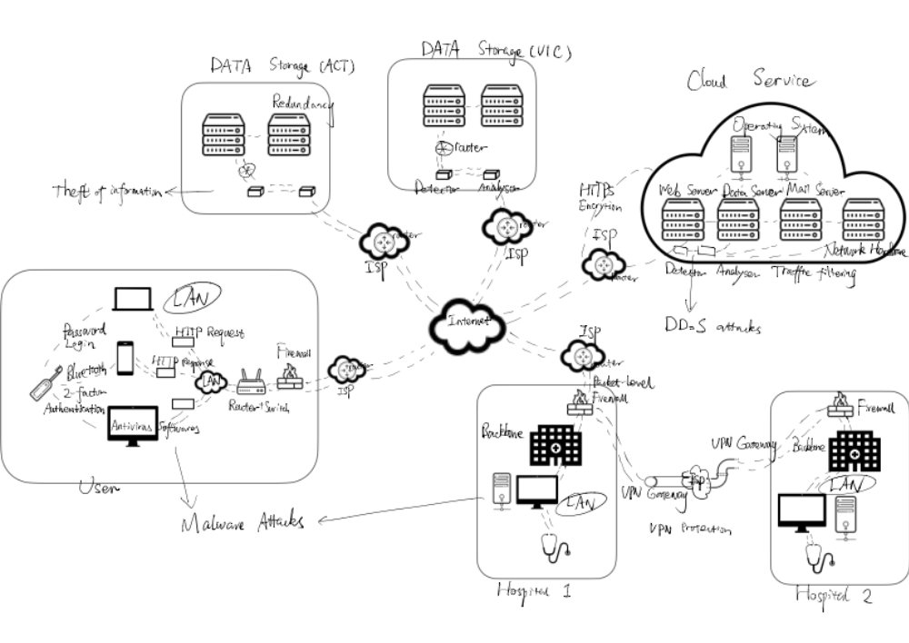
Web based app using HTTP protocols

4. Discussion

